COVER PAGE

REPLACE WITH BLUE COVER
PROVIDED

PROJECT EVALUATION
GROUP MEMBERS |  | STUDENT NUMBER
1.
2.
3.
4.
CONTENTS |  |  | MARKS
1. Synopsis of the system | - describe all the input data needed (2 marks)  - describe the process on how program works (2 marks)  - describe all the information (output) to be displayed (2 marks) |  | /06
2. Flow Chart | Diagrams - use correct diagrams |  | /04
 | Flow of Program - show logic flow |  | /04
 | Explanation - use words to explain the action |  | /04
 | Input - list all the variables needed |  | /04
 | Process - state all the process needed |  | /04
 | Output - list all the variables needed |  | /04
CO3:LO2 |  |  | /30
3. Source Code | Correctness - The system can solve the assigned problem and output should be as per the specifications. |  | /05
 | Reliability - The system should function accurately for a long period of time and also function correctly over all ranges and combination of data. |  | /05
 | User friendliness - Easy to use with enough information. |  | /05
 | Efficiency - Use of techniques covered and provides quality output.  - sequential (5 marks)  - selection (8marks)  - repetition (7 marks)  - function (5 marks)  - input /output statements (5marks) |  | /30
 | Readability of code - The source code should be simple and easy to understand. |  | /05
4. Screen output printed  - menu (2 marks)  - layout creativity (3 marks) |  |  | /05
5. Complexity of a program |  |  | /10
6. Overall effort in the project |  |  | /05
CO4:LO6 |  |  | /70
TOTAL |  |  | /100

TOTAL MARKS = / 100

TABLE OF CONTENTS

1.0 SYSTEM SYNOPSIS
- describe all the input data needed
- describe the process on how program works
- describe all the information (output) to be displayed

2.0 ANALYSIS AND FLOWCHART
Function menu ()
Input: | -
Process: | - BEGIN  - Display code and destination  - END
Output: | Display code and destination menu

Function menu ()
1.
2.
3.

Function calcPrice (int code,int quantity)
Input: | code and quantity
Process: | EXAMPLE  BEGIN  DECLARE double ticketPrice, totalPrice, insurance;  string destination;  If code = 1  Assign ticketPrice = 45;  Assign destination = “Kuala Lumpur”;  else if code = 2  Assign ticketPrice = 28  Assign destination = “Ipoh”;  else if code = 3  Assign ticketPrice = 55  Assign destination = “Kuala Terengganu”;  else  Assign ticketPrice = 0  Assign destination = “Invalid destination code”;  CALCULATE insurance = ticketPrice*0.05;  CALCULATE totalPrice = (ticketPrice + insurance) * quantity;  DISPLAY code, destination, quantity, ticketPrice, insurance, totalPrice  END
Output: | code, destination, quantity,ticketPrice,insurance,totalPrice

Function calcPrice (int code,int quantity)
1.
ii.

i.

3.
2.
4.
i.
ii.

ii.

5.
i.

6.
i.
ii.

7.

8.
9.

10.

Function main()
Input: | code, quantity, nextCustomer
Process: | - BEGIN  - DECLARE int code, quantity;  char nextCustomer;  - REPEAT if answer is yes  - Call function menu()  - Input code, quantity  - Call function calcPrice(code,quantity)  - Input repeat next customer  - DISPLAY “thank you” message  - END
Output: | -

Function main()
2.
1.
3.

yes
b.
a.
c.
no
4.
d.
5.

3.0 SOURCE CODE

#include <iostream>
using namespace std;
void menu(); //function prototype
void calcPrice(int,int); //function prototype

void menu() //function definition
{
}

void calcPrice(int code,int quantity) //function definition
{

}

int main()
{

}

4.0 SAMPLE OUTPUTS
Sample Output 1
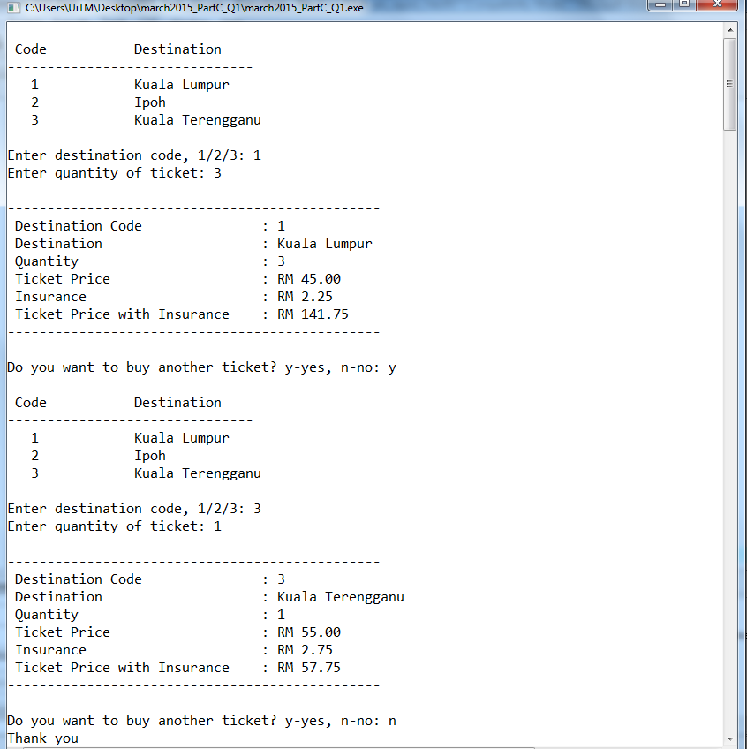

Sample Output 2

CD/DVD
in an Envelope

